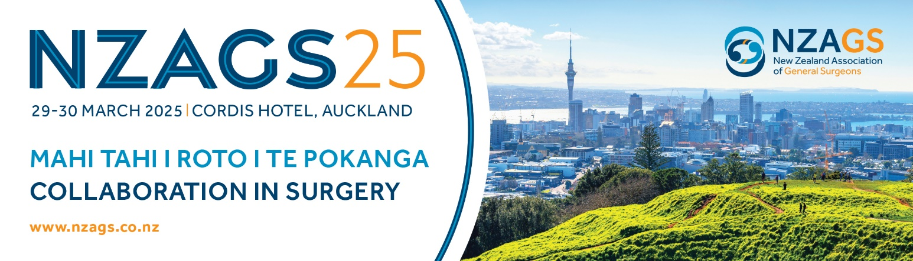

DELIVER TO:
NZAGS c/o
Cordis Hotel
83 Symonds Street
Auckland 1010
New Zealand
Attention: Anne Bickers(Conference Manager)

NZAGS 2023 Conference Manager:
Kimberley Wadsworth
NZAGS
+64 021 144 1793
conference@nzags.co.nz

For arrival no earlier than
Tuesday 24 March 2025

9.00-4.30pm only

CONTENTS INCLUDE:

DESCRIPTION OF CONTENTS:

SENDERS INFORMATION:

<<Company>>
<<Contact name for Onsite at Conference>>
<<Address 1>>
<<Address 2>>
<<Phone>>

Total # of Boxes: _________ This Box #: _________

